Parth Shukla
Lab 1
190905104

1)

counter = 100 # An integer assignment
miles = 1000.0 # A floating point
name = "Parth" # A string
print (counter)
print (miles)
print (name)

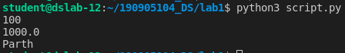

2)

counter = 100 # An integer assignment
miles = 1000.0 # A floating point
name = "Parth" # A string
print (counter)
print (miles)
print (name)

counter, name = 600, "Adam" # Multiple assignment
print(counter)
print(name)

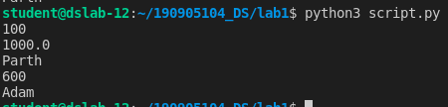

3)

Python Strings
str = 'Hello World!'
print (str) # Prints complete string
print (str[0]) # Prints first character of the string
print (str[2:5]) # Prints characters starting from 3rd to 5th
print (str[2:]) # Prints string starting from 3rd character
print (str * 2) # Prints string two times
print (str + "Lab 1") # Prints concatenated string

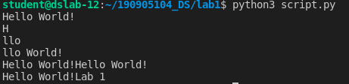

4) Updating string
var1 = 'Hello World!'
print ("Updated String :", var1[:6] + 'Python')

5) String formatting operator

print( "My name is %s and weight is %d kg!" % ('Parth', 65))

6) String methods

str = "this will have first letter in upper case"
print (str.capitalize())

str = "this will count the number of times some appears in the list"
print (str.count("count"))

str = "this will find the occurance some appears in the list"
print (str.find("occur"))

str= "CONVERT TO LOWER"
print (str.lower())

str= "SwApCaSe"
print (str.swapcase())

7) Lists

list = ['abcd', 1233, 33.4, "parth"]
print(list)
print(list[2:])
print(list[2:5])
print(list*2)

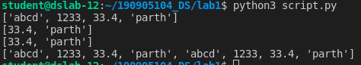

Add item
list = ['abcd', 1233, 33.4, "parth"]
list.append("last item")
print(list)

Delete item
list = ['abcd', 1233, 33.4, "parth"]
list.append("last item")
del list[2]
print(list)

list = ['abcd', 1233, 33.4, "parth"]
list.append("last item")
del list[2]
print(list)
print(len(list))
print(list.count("abcd"))
list.pop()
print(len(list))

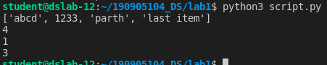

Remove item
list = ['abcd', 1233, 33.4, "parth"]
list.append("last item")
del list[2]
print(list)
print(len(list))
print(list.count("abcd"))
list.pop()
print(len(list))
list.remove("parth")
print(list)

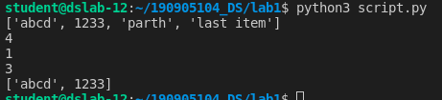

8) Tuple

tuple = ('abcd', 786 , 2.23, 'john', 70.2)
print(tuple)
print(tuple[2])

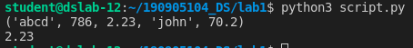

9) Branching and Looping

num=float(input("Enter a number:"))
if num>0:
print("pos number")
elif num==0:
print("zero")
else:
print("Neg number")

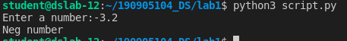

Never reaching condition:
x=float(input("Enter a number:"))
if x<20:
print("Below 20")
elif x<10:
print("Below 10")
else:
print("Above 20")

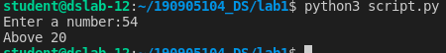

Nested If

x = 23
if x > 20:
print("passed first condition")
if x < 30:
print("passed second test")
else:
print("failed second test")

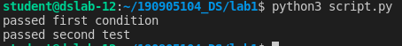

Ternary operator

age=15
b=("kid" if age<18 else "adult")
print(b)

Looping in list

list = ['abcd', 1233, 33.4, "parth"]
for l in list:
print(l)

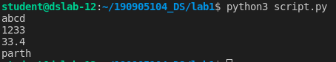

Print factors of a number

x=int(input("Enter a number:"))
for i in range(1,x+1):
if x%i ==0:
print(i)

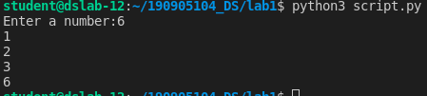

Finding largest element in list

from math import *
x= [9, 41, 12, 3, 74, 15]
Largest=-inf
for i in x:
if i>Largest:
Largest=i
print(Largest)

Similarly for smallest,

from math import *
x= [9, 41, 12, 3, 74, 15]
smallest=inf
for i in x:
if i<smallest:
smallest=i
print(smallest)

Finding mean of elements

x= [9, -3, 3, -2, 4, -5]
count=sum=avg=0
for i in x:
count=count+1
sum=sum+i
avg=sum/count
print(count)
print(sum)
print(avg)

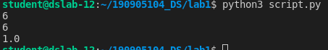

Filter elements in a list

res=[]
for i in x:
if i>20:
res.append(i)
print(res)

Replace all elements above 20 to zero and store in another variable

y=np.zeros(len(x))
for i in range(len(x)):
if x[i]>20:
y[i]=x[i]
print(y)

